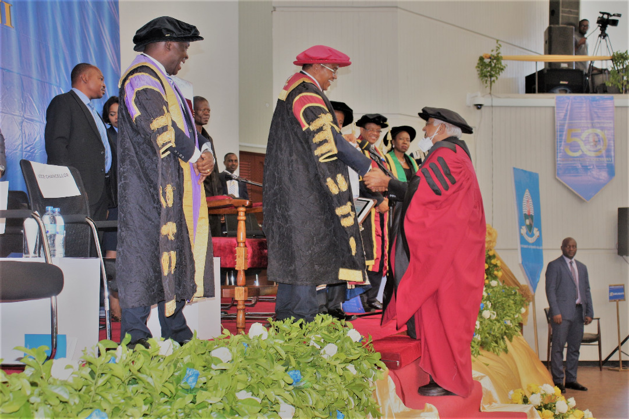
Prof. Emeritus Issa Gulamhussein Shivji receiving an Award of recognition from the Chancellor of the University of Dar-es-Salaam and retired President of the United Republic of Tanzania, Jakaya Mrisho Kikwete, at the 50th Graduation Ceremony of the University of Dar-es-Salaam held of 4th August 2020 at Nkrumah Hall, University of Dar-es-Salaam.

